**Department of Technical Education**

**Capstone project**

**Document CIE - 2**

Capstone project Title: Hospital Management System

Group Members: Pooja Patil [339CS17028

Pooja Mali [339CS20016]

Sneha Mali [339CS20028]

Swayam Patil [339CS20032]

1. **Description of technology used**

* **Web technology**

A place connected to the internet, where a company, organization, etc. Puts information that can be found on the World Wide Web.

* **Types of websites**
* Browsers
* HTML and CSS
* Programming Languages
* Frameworks
* Web Servers
* Databases
* Protocols
* Lastly, data Formats
* **Advantages**
* We can access from any location.
* No data loss.
* Data can be recovered.
* Be available every time.
* We can save time.
* **Cloud based technology**

To live the project we need to purchase cloud sever.

Cloud based technology is the use of software and services via the internet .These applications commonly include data storage, networking, servers and databases. User can access their cloud hosted tools with any device that is connected to the internet.

* **Types of cloud based technology**

1. **SAAS** :-Software as a Service.
2. **PAAS :**- Platform as a Service.
3. **IAAS :-**Infrastructure as a Service.

**Advantages**

* Usability and accessibility
* Security
* Cost efficient
* Convenient sharing of files
* Automation
* **Open-Source web technology**

For our project we not require to purchase any software’s and libraries.

* **XAMPP**

XAMPP is a cross-platform and open source tool, which makes it an ideal choice of web developers. It is the acronym of X-cross platform, Apache, MySQL, PHP, and Perl.

* **PHP**

PHP is an open source scripting language used for creating dynamic and interactive web pages and various digital platforms.

* **PhpMyAdmin**

PhpMyAdmin is an open source and free administration tool for MySQL

1. **Details of Hardware devices**

* **Processor:-**

The processor is a chip or a logical circuit that responds and processes the basic instructions to drive a particular computer. We have used average I3 processor. The core i3 processor is available in multiple speeds, ranging from 1.30GHz up to 3.50GHz and features either 3 MB and 4 MB of cache. Core i3 processor are found as dual-core having two cores.

* **Types of processor**
* **Microprocessor**

The general-purpose processors are represented by the microprocessor in embedded systems. There are different varieties of microprocessors available in the market from different companies.

* **Microcontroller**

The microcontroller is basically a computer that comes in various packages and sizes. The reading input and responding to output is the basic function of the microcontroller.

* **RAM**

Random access memory. It is one of the part of the main memory, also known as read write memory. Random Access memory is present on the motherboard and the computers data is temporarily store in RAM. We have used average RAM of 2GB to 4GB.

* **Types of RAM**
* **SRAM**(Static Random Access Memory)

SRAM is used for cache memory, it can hold the data as long as the power availability is there.

* **DRAM**(Dynamic Random Access Memory)

DRAM is used for the main memory, it has a different construction than SRAM, and it used one transistor and one capacitor which is needed to get recharged in milliseconds due to the presence of the capacitor.

* **Advantages**
  + - High speed.
    - Temporary memory (volatile).
    - Faster than secondary storage.
    - Fastest type of memory in a computer.
    - Consumes less power compared to disk drives hence increasing battery life.

1. **Details of software products**

Software products we have used in our project

* **PHP designer**

PHP Designer 8 is a fast and powerful PHP IDE and PHP editor with fill-blown HTML5, CSS3 and JavaScript built-in editors. Highly customizable IDE with intelligent syntax highlighting, debug support, syntax analysing support for object-oriented coding.

* **VS Code**

Visual Studio Code, also commonly referred to as VS Code, is a source-code editor made by Microsoft with the electron Framework, for windows, Linux and mavOS. Featuresinclude support for debugging, syntax highlighting.

* **XAMPP Server**

XAMPP is a cross-platform and open source tool, which makes it an ideal choice of web developers. It is the acronym of X-cross platform, Apache, MySQL, PHP, and Perl.

* **Operating System**

An operating system is system software that manages computer hardware and software resources, and provides common service for computing programs.

**Types of OS**

* Batch Operating system
* Time-sharing operating system
* Distributed operating system
* Network operating system
* Real-time operating system
* **Browser**

A browser is an application program that provides a way to look at and interact with all the information on the World Wide Web.

Types of browser

* Internet explorer
* Mozilla Firefox
* Google chrome
* Safari
* Microsoft edge

1. **Programming Languages**

* **HTML:-**

The hypertext markup language or HTML is the standard markup language for documents designed to be displayed in a web browser. It is often assisted by technologies such as CSS and scripting languages such as JavaScript.

* **Advantages of HTML:-**
* HTML is simple to understand and implement.
* Html is completely free.
* HTML is simple to edit.
* HTML is light weight and quick.
* **CSS:-**

Cascading style sheet is a style sheet language used for describing the presentation of a document written in a markup language such as HTML.CSS is a cornerstone technology of the World Wide Web.

* **Advantages of CSS:-**
* CSS saves time
* Easy maintenance
* Global web standards
* Platform Independence
* **JavaScript:-**

JavaScript is a scripting language that enables you to create dynamically updating content, control multimedia, animate images, and pretty much everything else.

* Advantages of JavaScript:-
* Interoperability.
* It offers procedural programming features.
* Simpalicity.
* Speed.
* **Bootstrap:-**

Bootstrap is a free and open source CSS framework directed at responsive, front end web development. It contains HTML, CSS and java script based design templates for forms, buttons, navigation, etc.

* **Advantages of Bootstrap:-**
* Bootstrap is easy to use.
* Fast & time-saving framework.
* Support is amazing.
* Bootstraps consistency.
* **PHP :-**

PHP hypertext preprocessor is a widely used open source general purpose scripting language that is especially suited for web development and can be embedded into HTML.PHP pages contains HTML with embedded code.

* Advantages of PhP:-
  + - Extremely scalable.
    - Free to use.
    - Support of community.
    - Easy to use.
* **MYSQL :-**

MySQL is a relational database management system developed by oracle that is based on structures query language MySQL is one of the most recognizable tectnologics in the modern big data ecosystem. MySQLis integral to many of the most popular software stacks for building and maintaining everything from customer-facing web applications

* **Advantages of MYSQL:-**
* Bootstrap is Easy to Use
* Fast and time -saving Framework
* Support is Amazing
* Bootstraps Consistency

1. **Description of the components in the system**

* **Book appointment :-**

Here user can book the appointment online with their correct details. If they didn’t put their correct details they the form will not submit. After booking appointment they can meet to doctor

* **Reception login:-**

Reception can login to the form using username and password. Reception must login with their correct details. After logging in he is able to see all the appointments.

* **View appointment:-**

After user will book appointments that will managed by reception. Reception should view all the appointments. And he/she must manage all different types of appointments.

* **Add patient details:-**

After reception login Reception must manage patients according to their correct details. he/she can add patients.

* **Bill collection:-**

Reception manages all the bill collections. If he did wrong then the page will not submit.

* **Doctor login:-**

Doctor can login to the form using username and password. Doctor must login with their correct details. .

* **Manage patients:-**

Doctor must manage all the patients. And doctor must view patients according to appointments. Doctor can approve and disapprove appointments.

* **Medicine list:-**

After checkup doctor will give the medicine list to the patients.

1. **Component diagram**

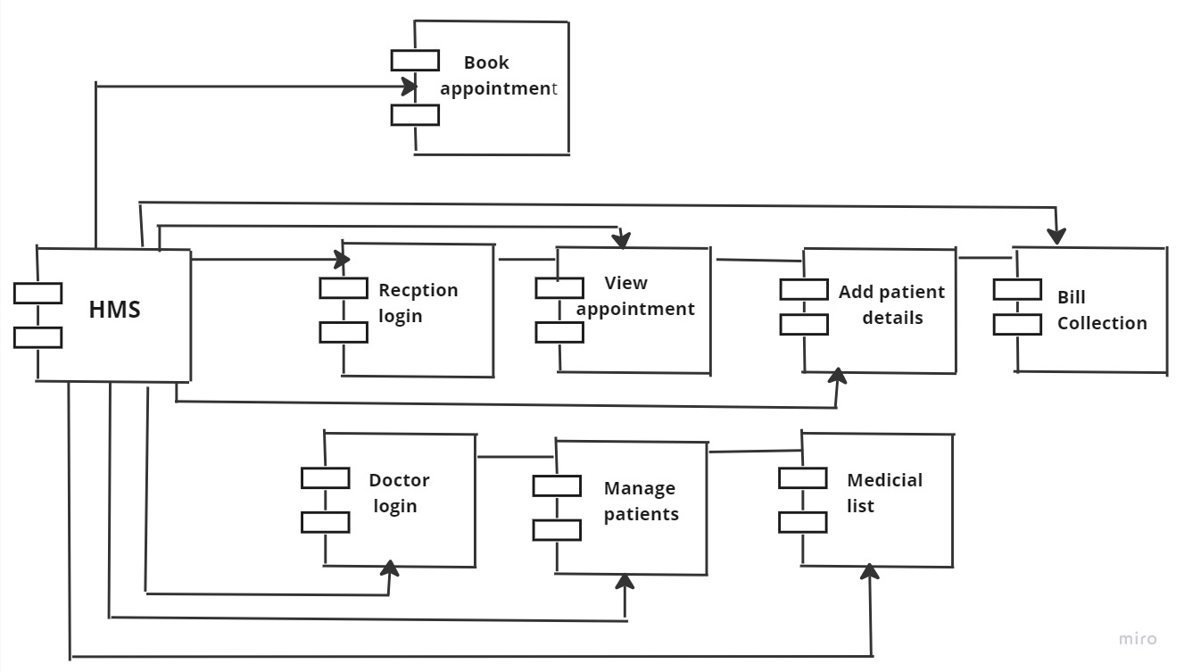

**Use Case**

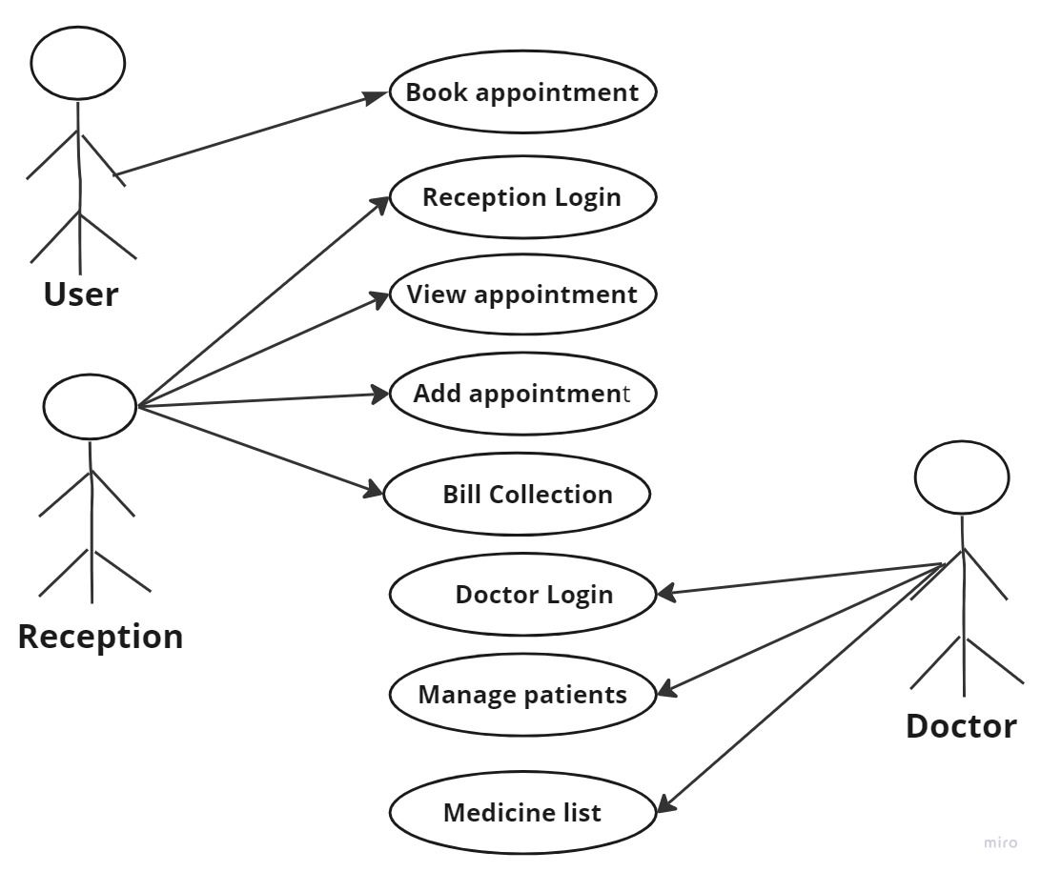

1. **Construction or Fabrication details**

* **Book appointment** :-

Here user can book the appointment online with their correct details. If they didn’t put their correct details they the form will not submit. After booking appointment they can meet to doctor

* **Reception login:-**

Reception can login to the form using username and password. Reception must login with their correct details. After logging in he is able to see all the appointments.

* **View appointment:-**

After user will book appointments that will managed by reception. Reception should view all the appointments. And he/she must manage all different types of appointments.

* **Add patient details:-**

After reception login Reception must manage patients according to their correct details. he/she can add patients.

* **Bill collection:-**

Reception manages all the bill collections. If he did wrong then the page will not submit.

* **Doctor login:-**

Doctor can login to the form using username and password. Doctor must login with their correct details. .

* **Manage patients:-**

Doctor must manage all the patients. And doctor must view patients according to appointments. Doctor can approve and disapprove appointments.

* **Medicine list:-**

After checkup doctor will give the medicine list to the patients.

**System Architecture Diagram:-**

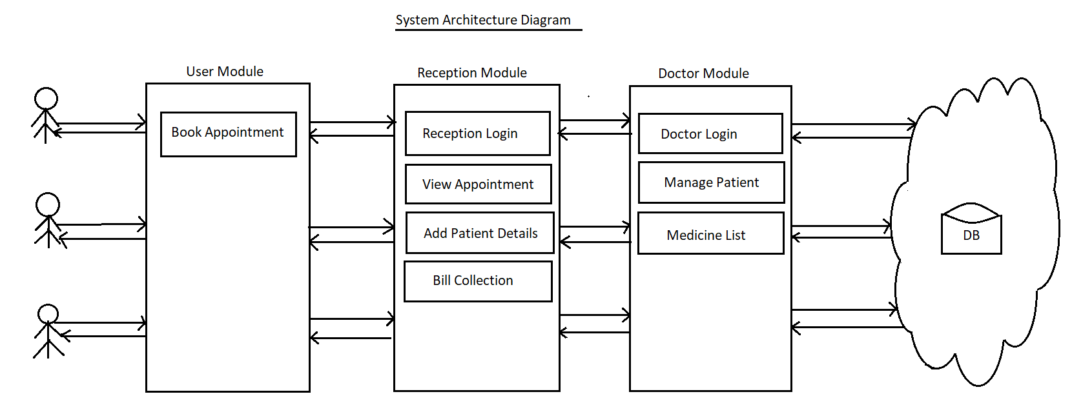

1. **Any other information needed to execute the Capstone project**

* **XAMPP Server**

XAMPP is a cross-platform and open source tool, which makes it an ideal choice of web developers. It is the acronym of X-cross platform, Apache, MySQL, PHP, and Perl.

**Steps to run program using XAMPP Server**

1. Open XAMPP Server control panel.
2. Start apache and MySQL service.
3. Minimize the windows.
4. Open browser.
5. In URL address bar type root folder name with local host (local host/cbktest).

**To live the program on cloud server**

1. Purchase web domain name and cloud hosting server from any software company.
2. After purchase using username and password login to the cloud server and configure the project.

Signature of the Cohort owner